Mrs. Keesler’s Classroom Newsletter
Dear Parents
Our year is off to a great start! The students in Room 14 are eager and ready to learn. I am looking forward to meeting with you at our Back to School Night, tomorrow night, Tuesday, September 15th at 7:30. You will begin in the gym with a 10 minute presentation about our new math program and then you will travel to my room for the remainder of the evening. I hope to see everyone here. If you are unable to make it I will be sending some information home on Wednesday.
Constitution Day is this Thursday. Hopefully the students are working on memorizing their preamble. I have already heard several students say the preamble. I am so proud of them. Hopefully by Thursday I will hear from all the students and everyone will have earned their flag!
Mark your calendars for Harvest Hoopla it is Friday, October 9th. Please watch for more information to come home about this amazing event.
This week the students will be beginning Words Their Way for Spelling. This will provide the students with spelling lists at their level and help them to build an understanding of spelling rules and patterns in words. I have tested the students to find out their individual spelling levels and they will be receiving a list of spelling words based on those results. It is important to remember that spelling in not about memorizing the words, but about learning the spelling patterns.
I will be working this week to set up our class e-mail list. You can always e-mail me at: kkeesler@lakeshoreps.org and then I will add you to the class list. Once I have everyone’s e-mails entered you will then begin to receive our class newsletter via e-mail.

Notes from me:

Stewart Elementary

9-14-15


Mrs.Keesler’s
Classroom


NWEA/MAP Testing
On Tuesday and Friday morning the students will be taking the reading and Math MAP (Measures of Academic Progress) tests in the computer lab. To help them feel confident when testing please help ensure they are getting a good night’s sleep the night before. The testing takes about one hour and we simply ask the students to just do their best and try their hardest.

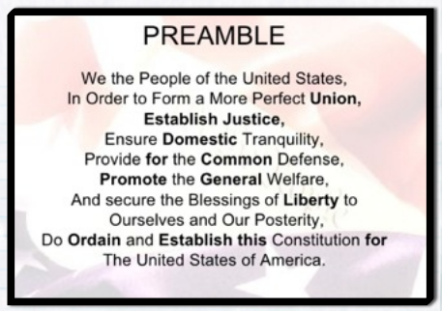

Mrs. Keesler’s Classroom Newsletter Page 2

Upcoming Events
MAP testing:
Tuesday 9-15- Reading
Friday 9-17- Math
Late Start Wednesday:
Wednesday 9-16 is our first late start. Doors open at 9:10
Pictures:
Thursday 9-17- please send in money by this Thursday.
Book Orders:
Due Friday, September 26th
Harvest Hoopla:
Friday, October 9th

HOMEWORK
Monday: Home Connection (HC) pg. 1-2 DUE WEDNESDAY
Tuesday: Study spelling words, Finish HC Due Wednesday
Wednesday: Study spelling words, HC Of Mice & Moles DUE Friday
Thursday: Study spelling words, finish math of Mice and Moles Due Friday

Math: We are continuing to work on our first unit reviewing addition and subtraction strategies. This week we are focusing on our subtraction strategies.
Language Arts: The students will read “Dear Juno.” We will be focusing on character traits.
Writing: We will be working on our first unit of writing, which is a personal narrative. The students will be working on writing a descriptive personal narrative about a special time with someone special.
Social Studies: The students are continuing to learn, where in the world we live. This week we will finish up our study of where in the world we live. They will take a Continents and Oceans quiz on Tuesday (9-22) to review the information they have learned. There is a world map in their assignment book that they may use to help them study. They will also bring home a study guide on Friday. They may also wish to visit http://www.sheppardsoftware.com/World_Continents.htm to play some games to help them identify the continents and oceans.

Sneak Peeks at our Week
SPECIALS:
Monday: Physical Education

Tuesday:
Art

Wednesday
Physical Education Library

Thursday: Music

Friday: Guidance

Spelling Words:
Since we are using Words Their Way we have five different spelling groups. Tomorrow your child will receive their personalized spelling list and put it in the page protector sheet that their other spelling words are to be kept in all year. Please help them to review and study their words through the week. I will also be sending home a sheet about great ways for them to practice their spelling words at home.
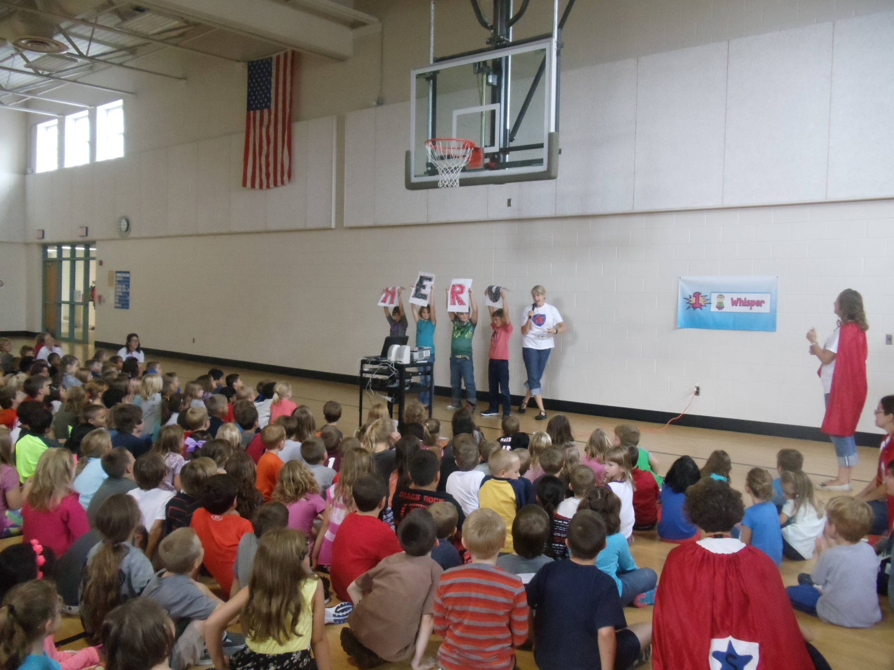
The students had a blast at our assembly on Friday. They got to work on their new super hero voice levels from 0 all the way to 4.



